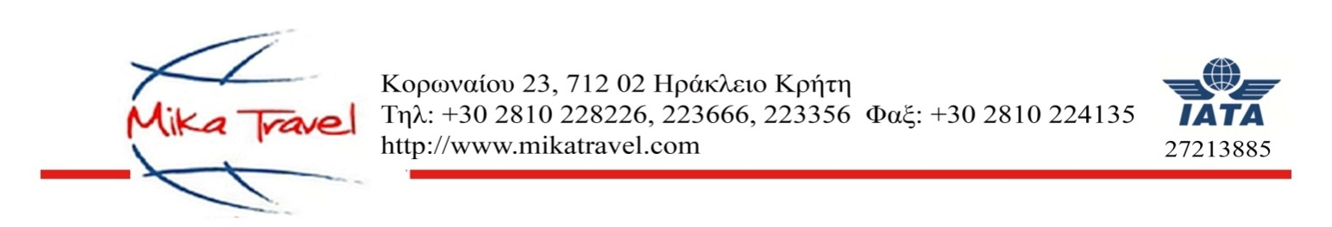

COMPDYN 2019

SHUTTLE BUS REGISTRATION FORM/ PAYMENTS DETAILS

Arrival Date | Flight No | Arrival Time | Pax No | NAME | Drop off Hotel

Arrival Date | Flight No | Arrival Time | Pax No | NAME | Drop off Hotel
Dep. Date | Flight No | Dep.Time | Pax No | NAME | Pick up Hotel

Price per person per way 15€

METHOD OF PAYMENT

- By Bank transfer to the order of MIKA TRAVEL DIMITRA MYKONIATI
(Please state your name on the bank transfer)

NATIONAL BANK OF GREECE
IBAN: GR58 0110 2050 0000 2050 0441 561
BIC: ETHNGRAA

b) By credit card
Date: ..../..../....
I hereby authorize the agency Mika Travel to charge on the following credit card the amount of .......... Euro
Visa Mastercard

Card No.: Expiry Date__________ CVV _______

Card Holder name: Signature: ___________________

Date:___________________

